Name: - Aastha Sapate

Factory-to-Customer Shipping Route Efficiency Analysis for Nassau Candy Distributor

Abstract
Efficient logistics and supply chain management play a critical role in ensuring customer satisfaction, reducing operational costs, and improving business profitability. Nassau Candy Distributor operates across multiple regions and relies on an extensive shipping network to deliver products from factories to customers. This project focuses on analyzing shipping route efficiency using order and shipment data. The objective is to identify efficient and inefficient routes, analyze shipping performance across regions and ship modes, detect geographical bottlenecks, and provide actionable recommendations. Python, Pandas, Plotly, and Streamlit were used to perform data analysis and develop an interactive dashboard. The findings reveal significant differences in route performance, lead times, and regional shipping efficiency, enabling data-driven decision-making for logistics optimization.

1. Introduction
In modern supply chain management, transportation and logistics efficiency are essential for maintaining competitive advantage. Organizations that can deliver products quickly and reliably gain higher customer satisfaction and improved operational performance.
Nassau Candy Distributor is a large-scale distributor that transports products from factories to customers across various regions. As shipment volumes increase, it becomes necessary to evaluate the efficiency of transportation routes and identify factors affecting delivery performance.
This project aims to transform raw shipment data into meaningful business intelligence by analyzing shipping lead times, regional performance, route efficiency, and shipping modes. The analysis helps identify bottlenecks and opportunities for logistics optimization.

2. Problem Statement
The organization currently lacks visibility into the performance of its shipping routes. Without detailed route-level analysis, management faces difficulties in answering the following questions:
- Which routes are consistently efficient?
- Which routes experience frequent delays?
- How does shipping performance vary across regions?
- Which ship mode performs best?
- Where do operational bottlenecks exist geographically?
- How can logistics efficiency be improved?
Without data-driven insights, optimization decisions remain reactive rather than strategic.

3. Objectives of the Study
The major objectives of this project are:
- Analyze shipping lead times across routes.
- Identify the most efficient and least efficient routes.
- Compare performance across different shipping modes.
- Evaluate regional shipping efficiency.
- Detect geographic bottlenecks and delay-prone areas.
- Build an interactive dashboard for decision-making.
- Provide actionable recommendations to improve logistics performance.

4. Dataset Description
The dataset contains order-level and shipment-level information for Nassau Candy Distributor.

Important Attributes
Field | Description
Order ID | Unique order identifier
Order Date | Date order was placed
Ship Date | Date order was shipped
Ship Mode | Shipping method
Customer ID | Customer identifier
Region | Customer region
State/Province | Customer state
Product Name | Product name
Sales | Sales amount
Gross Profit | Profit generated
Cost | Manufacturing cost

Additional Reference Tables
The project also includes:
- Factory coordinates
- Product-to-factory mapping
- Factory location information
These tables help establish route relationships between factories and customer destinations.

5. Methodology
The project follows a structured analytics workflow.

5.1 Data Collection
The shipment dataset was imported into Python using Pandas.
df = pd.read_csv("Nassau Candy Distributor.csv")

5.2 Data Cleaning
Data preprocessing included:
- Converting date fields into datetime format
- Handling missing values
- Removing invalid records
- Standardizing categorical fields
Example:
df["Order Date"] = pd.to_datetime(df["Order Date"])
df["Ship Date"] = pd.to_datetime(df["Ship Date"])

5.3 Feature Engineering
A new metric called Shipping Lead Time was created.

Formula
Lead Time = Ship Date − Order Date
df["Lead Time"] = (
df["Ship Date"] - df["Order Date"]
).dt.days
This metric serves as the primary KPI for evaluating shipping efficiency.
5.4 Route Definition
Each route was defined using customer location information.
Example:
Region → State
This enabled route-level aggregation and performance comparison.

5.5 Exploratory Data Analysis
EDA was conducted to understand:
- Sales distribution
- Profit distribution
- Regional performance
- Shipping mode efficiency
- Route efficiency
Visualization techniques included:
- Bar charts
- Pie charts
- KPI cards
- Route rankings
- Geographic analysis
6. Key Performance Indicators (KPIs)
The following KPIs were used:
Total Orders
Represents the total number of customer orders processed.
Total Sales
Measures overall revenue generated.
Gross Profit
Measures profitability after deducting costs.
Shipping Lead Time
Measures delivery duration.
Route Efficiency Score
Evaluates route performance based on lead time.
Delay Frequency
Percentage of shipments exceeding acceptable thresholds.

7. Exploratory Data Analysis

7.1 Sales Analysis
Regional sales analysis revealed significant differences across customer regions.
Key observations:
- Some regions contribute substantially more revenue.
- Sales concentration exists in specific geographic areas.
- High-volume regions require continuous logistics monitoring.

7.2 Profit Analysis
Profit distribution showed that certain regions generate higher margins despite lower sales volume.
Key observations:
- Revenue does not always correlate with profitability.
- Some routes may be financially efficient despite lower shipment volumes.
7.3 Product Performance Analysis
Top-selling products were identified.
Findings:
- A small group of products contributes a large percentage of revenue.
- Product demand varies by region.
- Inventory planning should prioritize high-performing products.
8. Route Efficiency Analysis
Route efficiency was analyzed using average shipping lead time.

Most Efficient Routes
Characteristics:
- Low lead time
- Consistent delivery performance
- Reliable transportation infrastructure
Benefits:
- Improved customer satisfaction
- Reduced logistics costs
- Better operational planning

Least Efficient Routes
Characteristics:
- High lead time
- Significant variability
- Higher probability of delays
Potential causes:
- Distance-related challenges
- Transportation bottlenecks
- Resource limitations
Recommendations include route redesign and shipment consolidation.

9. Geographic Bottleneck Analysis
Geographic analysis was conducted to identify delay-prone states and regions.

Findings
Certain regions consistently exhibit:
- Higher lead times
- Greater shipment variability
- Increased operational risk
Possible causes include:
- Traffic congestion
- Infrastructure limitations
- Long-distance transportation requirements
These locations should receive priority attention for logistics optimization.

10. Ship Mode Performance Analysis
Different shipping methods were compared based on average lead time.

Standard Class
Advantages:
- Lower transportation cost
Disadvantages:
- Longer delivery duration

First Class
Advantages:
- Faster delivery
Disadvantages:
- Higher cost

Second Class
Balanced performance between cost and speed.

Same Day
Fastest shipping option but suitable only for specific scenarios.
Findings suggest that shipping mode selection significantly influences route efficiency

11. Dashboard Development
An interactive Streamlit dashboard was developed to visualize logistics performance.

Dashboard Features
- KPI Cards
- Region Filter
- Ship Mode Filter
- Sales Analysis
- Profit Analysis
- Route Efficiency Analysis
- Geographic Analysis
- Product Analysis

Technologies Used
- Python
- Pandas
- Plotly
- Streamlit
Benefits:
- Real-time insights
- User-friendly interface
- Interactive filtering
- Executive-level reporting

12. Screenshots

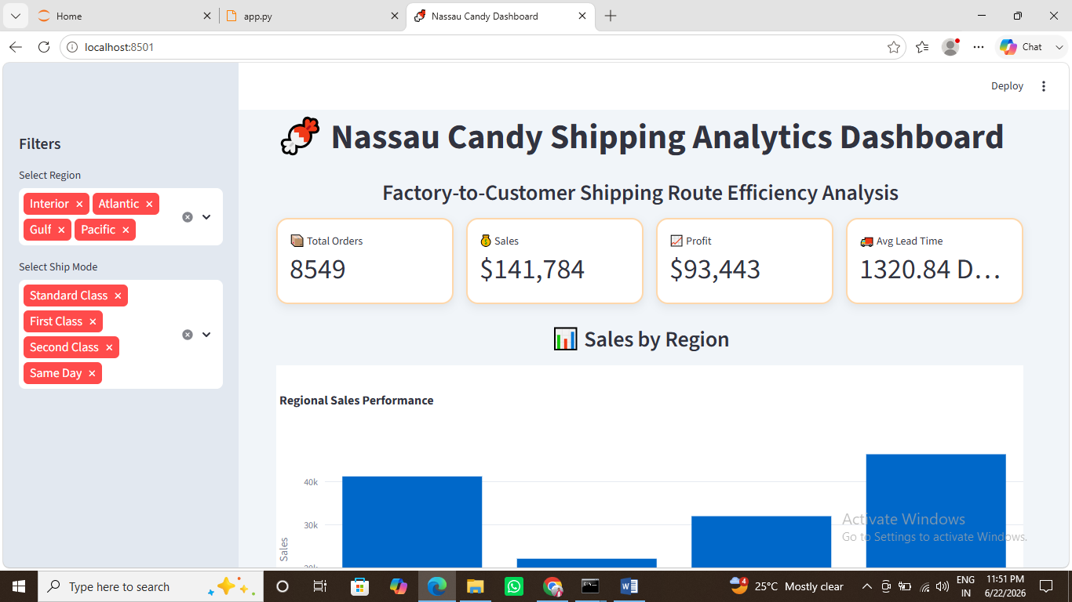

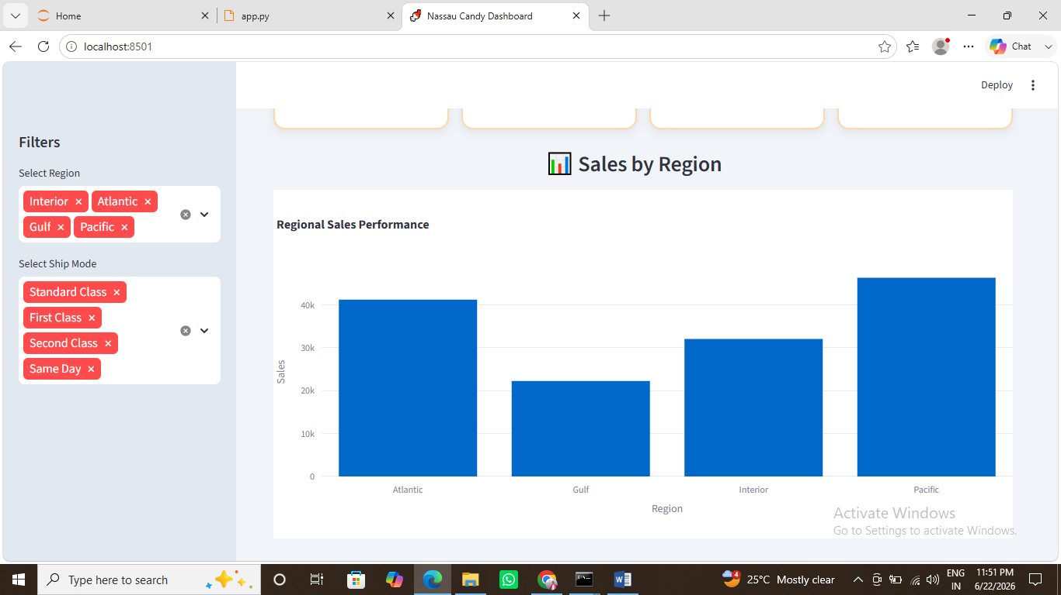

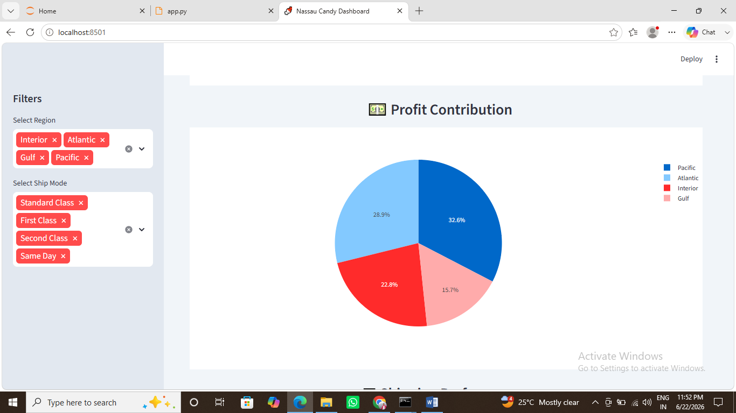

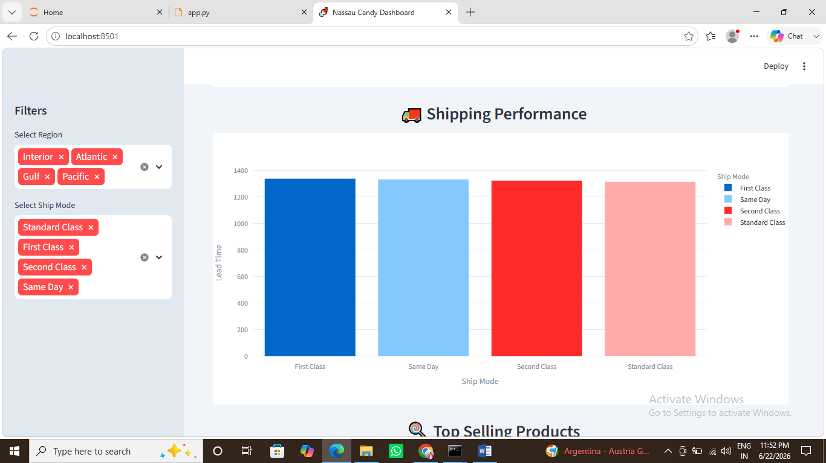

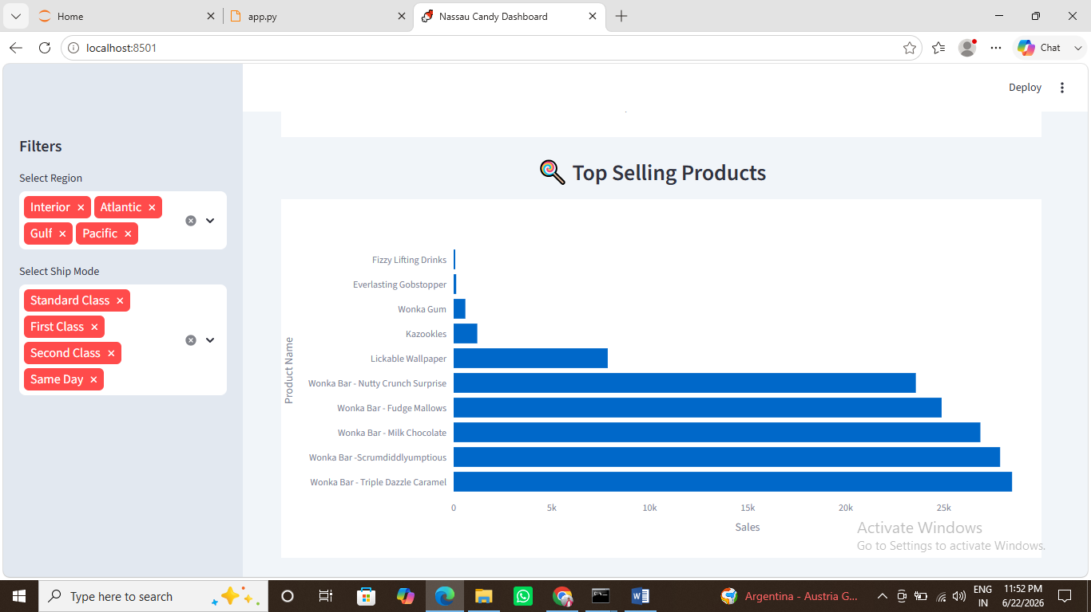

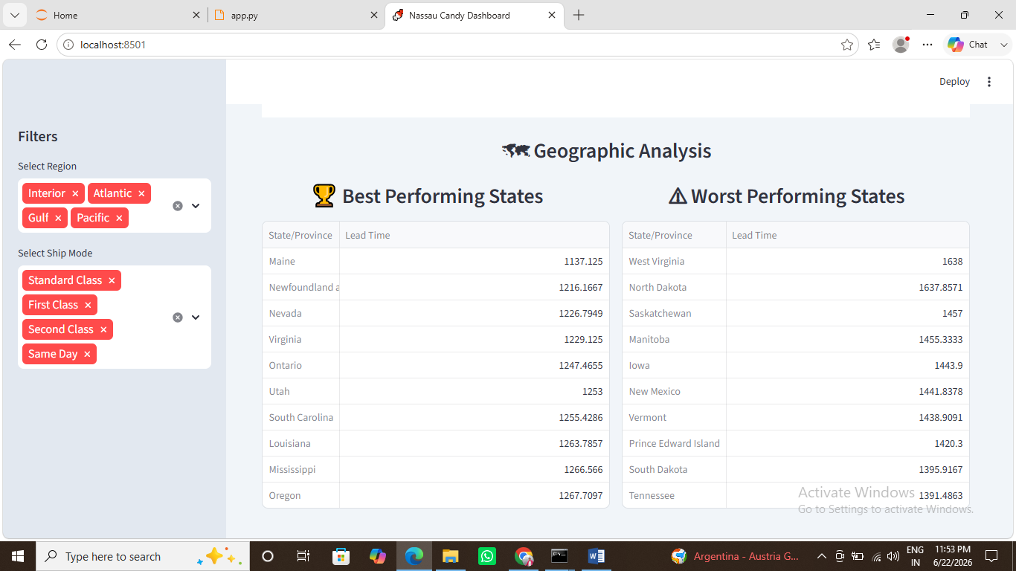

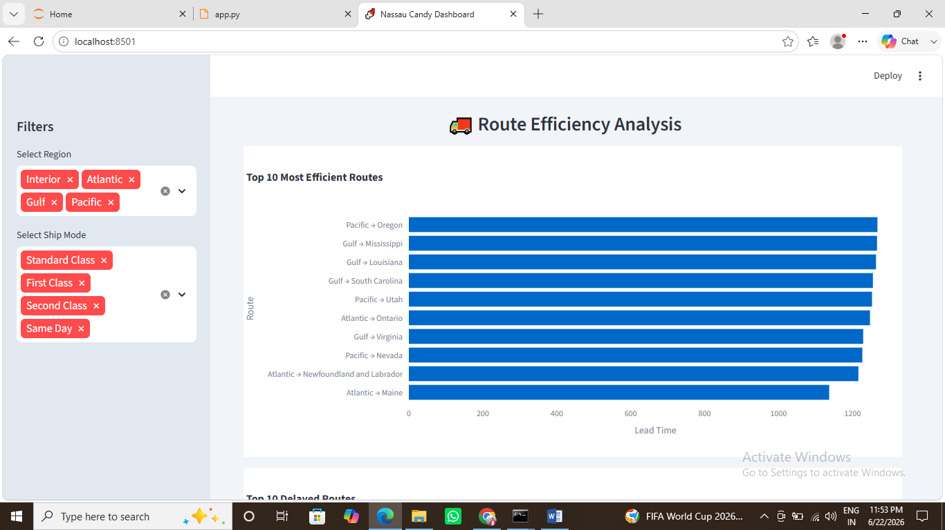

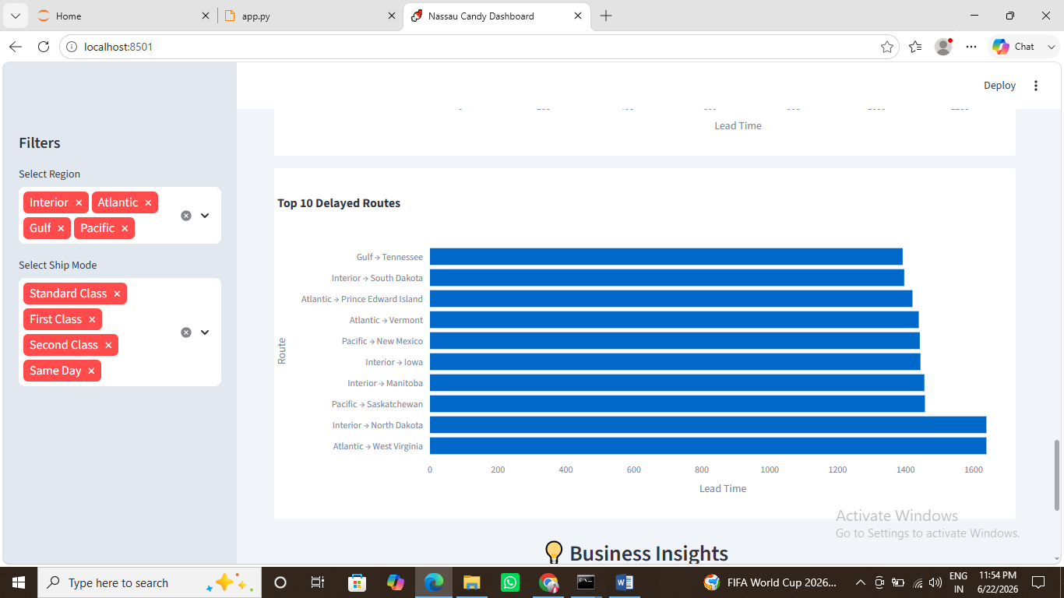

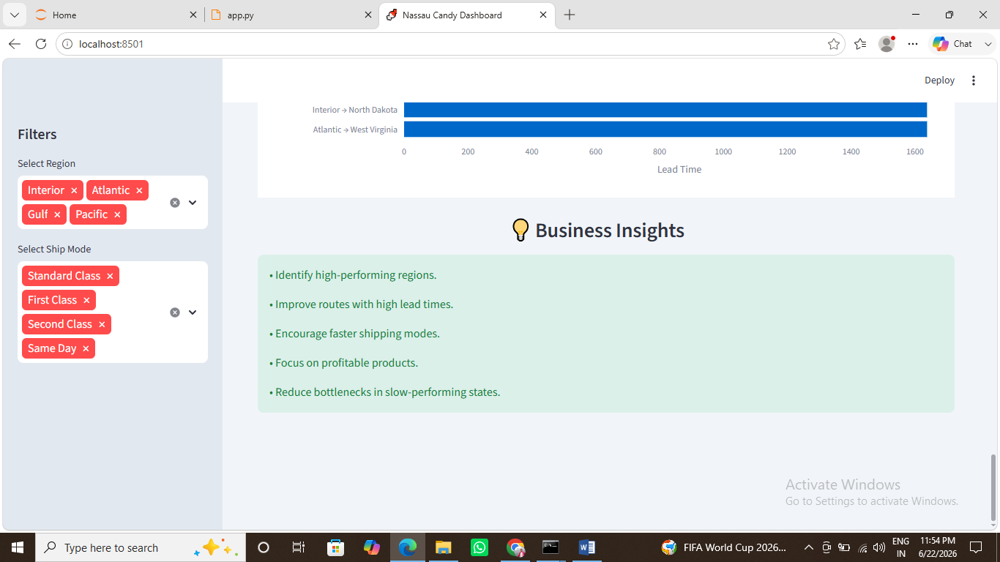

13. Business Recommendations
Based on the analysis, the following recommendations are proposed:
- Optimize high-delay routes.
- Increase usage of efficient shipping modes.
- Improve infrastructure planning in bottleneck regions.
- Prioritize high-profit products.
- Monitor route performance continuously.
- Develop predictive models for delay forecasting.
- Use route-level KPIs for operational decision-making.

14. Future Scope
Future enhancements may include:
- Machine Learning-based delay prediction
- Real-time shipment tracking
- Route optimization algorithms
- Cost-efficiency analysis
- Geographic Information System (GIS) integration
- Automated logistics recommendations
These enhancements can further improve supply chain intelligence and operational efficiency.

15. Conclusion
This project successfully analyzed factory-to-customer shipping route efficiency for Nassau Candy Distributor. By transforming raw order and shipment data into actionable insights, the study identified efficient routes, delay-prone locations, and performance differences across shipping methods and regions.
The developed Streamlit dashboard provides a practical decision-support tool for logistics managers and business stakeholders. The findings demonstrate that route-level analysis can significantly improve operational efficiency, reduce delays, and enhance customer satisfaction. Data-driven logistics management will enable Nassau Candy Distributor to optimize transportation performance and strengthen its competitive advantage.

References
- Pandas Documentation
- Streamlit Documentation
- Plotly Documentation
- Supply Chain Management: Strategy, Planning and Operation
- Logistics and Transportation Management Research Papers
- Unified Mentor Project Guidelines

